ENRICO FERMI SCHOOL

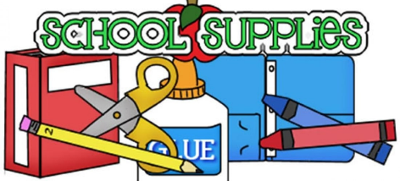

SUBJECT: Science

GRADES: 7th & 8th

Mrs. López-Ortiz

* 2 composition notebooks
* 1 box of Highlighters
* Medium Post-its
* 1 box of sharpened # 2 pencils
* 1 pack of erasers
* 2 glue sticks
* Index cards 3x5 in. (vocabulary)
* 1 pack of large rings
* 2 durable folders with pockets
* 2 packs of medium size construction paper
* 4 Lysol wipes (to clean their desks)
* Face masks
* 4 bottles of Purell Hand Sanitizer

NOTE: Please send the following supplies to school by Monday, September 14, 2020.